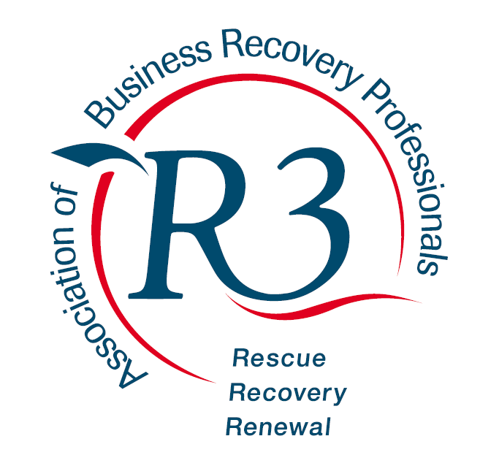

Association of Business Recovery Professionals
R3 Yorkshire

Notice is hereby given that the Annual General Meeting of The Association of Business Recovery Professionals Yorkshire Region will be held at King’s Chambers on 14 May 2024 at 8:30 for the purpose of considering and, if thought fit, passing the following resolution:

That the Ordinary Members (as detailed below) of the Regional Committee be approved:

Name | Firm | Position
 |  | Chair
Jodie Wildridge | Exchange Chambers | Vice-chair
Vacant |  | Regional OR Liaison
Vacant |  | Council member
 |  | Committee member
 |  | Committee member
 |  | Committee member
 |  | Committee member
 |  | Committee member
 |  | Committee member
 |  | Committee member

Applications are also invited from other membership wishing to join the committee and they are invited to contact Eleanor Temple KC etemplekc@kingschambers.com to register their interest.

